Preparation

Connect the arm motor to the control board (see the wiring documentation)
Connect the mega2560 to the computer's USB port.

Program burning
Open the marlin file in the marlin folder.
Select the corresponding serial port and development board.
The serial port is selected based on the actual connection.
The development board and processor are selected according to the figure.
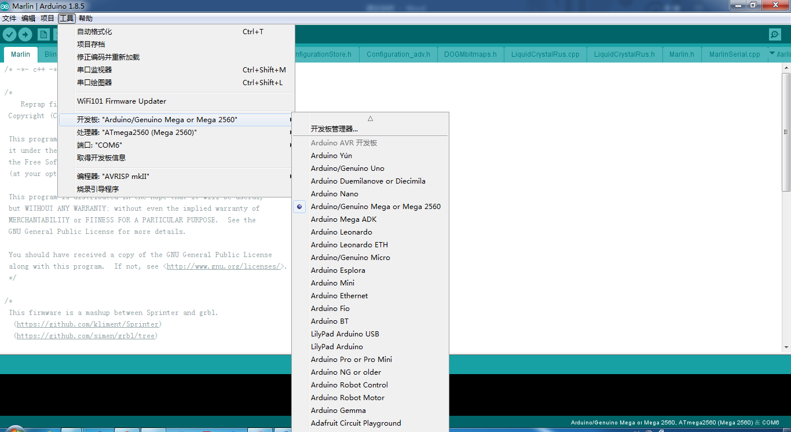

Then click the Upload button in the toolbar above and wait for the program to upload successfully. Then move to the next step.


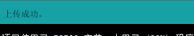

Open the host computer software
Open the folder and find the pronterface.exe file and double-click to open it.

Introduction to the Pronterface interface

Modify the parameters as shown:

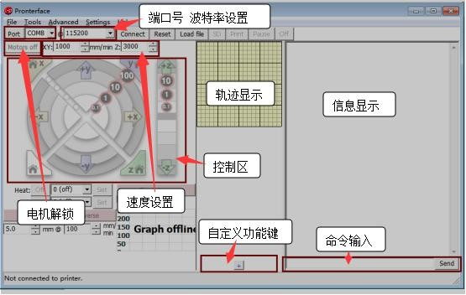
端口号 波特率设置
轨迹显示
信息显示
控制区
电机解锁
自定义功能键
命令输入

Connect and disconnect:

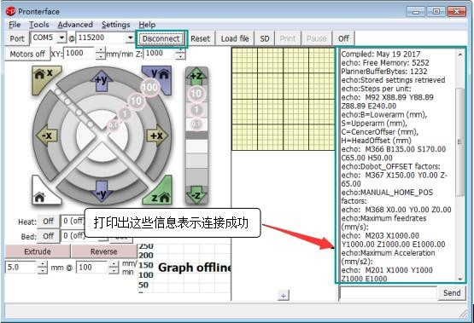
Click the connect after setting the communication parameters, , the information shows up in the figure means a successful connection. To disconnect, just click disconnect.

Initialization of Robot Arm Parameter
Input M502 to read program memory parameter
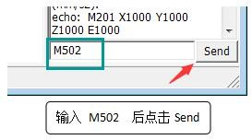( input M502, and then click send)

Enter M500 , and save the parameters in the memory to the EEPROM
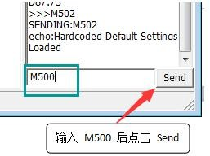(input M500 and click send)

The two steps above indicate that the default settings are restored. These steps are required after re-downloading the firmware.

Adjustment of Robotic arm Initial posture

The arm must first be calibrated to initial posture before control it.

Input G95 to find Angle coordinate

Input G1 X10 Y10 Z10
( Enter the corresponding degree according to the actual situation, and adjust the arm to the posture shown in the figure below : the boom is 90 degrees to the horizontal ,the arm is parallel to the horizontal line.Manually adjustment is feasible, but it is not commended here because it will cause an extensive damage for the motor shaft connection position.)

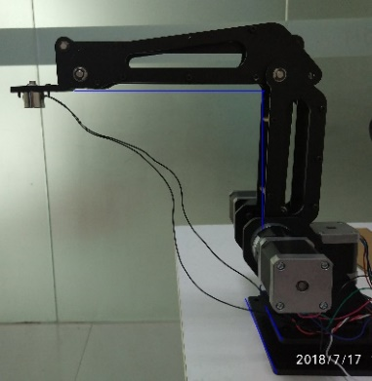

After calibration, enter G93 X90 Y0 Z0 ( the current attitude of the robot arm: the boom is 90 degrees, the arm is 0 degrees, and the basis is 0 degrees).

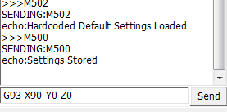

If the arm does not move after the G1 command is input, check the speed first . If the speed is too low, the arm won’t move, please reset the speed by adding F1000 behind the input displacement command.
Second, check the software limit, whether it is triggered. That is, to check weather the arm can finish the motion of the three axes in the forward and reverse directions in turn. If one axis can only move in one direction, input G93 X45 Y45 Z45 to adjust the angle coordinates. Input G95, then you can re-adjust the arm position with the G1 command.
Next, check the motor wiring. To check whether it is plugged in.
Then, check the number of pulse. Whether the number set in the marlin source program appropriate or not.

Work point location
Enter G95 to switch to the angle coordinate system.
Enter G94 to switch to the Cartesian coordinate system.
Enter G1 X0 Y0 Z0 F1000 (F stands for speed, unit mm/min) to adjust the end of the arm to run to the default offset origin position. The blue below is the absolute coordinate system, and the red is the relative coordinate system. By default, the axes of the two coordinate systems have the same direction and the XOZ is under planes coincide. The two coordinate systems are as shown:
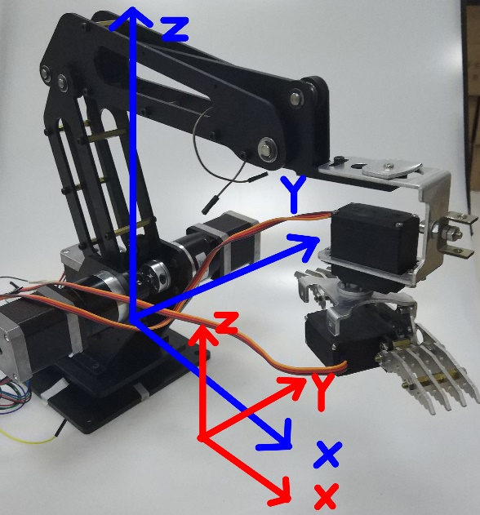

If you need to adjust the origin position of the relative coordinate system, which doesn’t need to be adjusted generally, input G93
And then
Enter G95 to switch to the angle coordinate system.
Enter G94 to switch to the Cartesian coordinate system.
Enter G1 to move to the position that wanted to be set as the origin of the coordinate.
Enter M367 X0 Y0 Z0 to adjust the offset to zero.
Enter M114 to view the current coordinate value and note the target coordinate value.
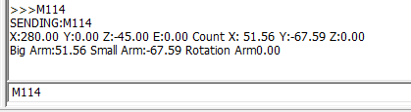

Enter M367 and enter the coordinate value that just has recorded.
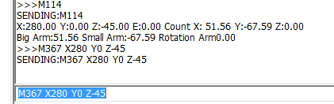
Enter M500 to save to EEPROM.
There, the coordinate origin can be redefined by above steps.

